US REGENTS REVIEW
4. Turning Points
Explain how the following events/time periods could be considered Turning Points in U.S. History. Identify the positive and negative effects.

Events/Time Periods:
Louisiana Purchase PG 12
Why a T.P.? | + Effects | - Effects
Reconstruction PG 16
Why a T.P.? | + Effects | - Effects
Spanish American War PG 22
Why a T.P.? | + Effects | - Effects
Stock Market Crash of 1929 PG 25
Why a T.P.? | + Effects | - Effects
FDR’s New Deal PG 26
Why a T.P.? | + Effects | - Effects
Manhattan Project PG 28
Why a T.P.? | + Effects | - Effects
Vietnam War PG 30
Why a T.P.? | + Effects | - Effects
Civil Rights Movement PG 31
Why a T.P.? | + Effects | - Effects
9/11 PG 34
Why a T.P.? | + Effects | - Effects

1) 4)
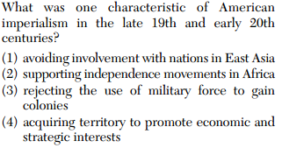
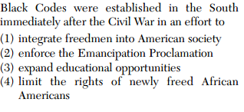

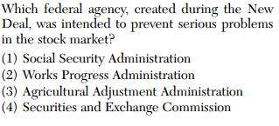
2)
5)
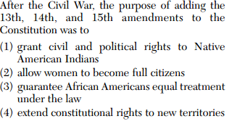

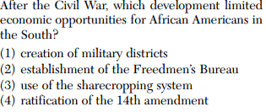
3)

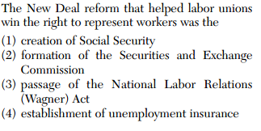
6) & 7) 8)
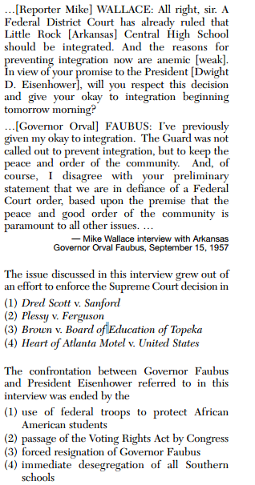

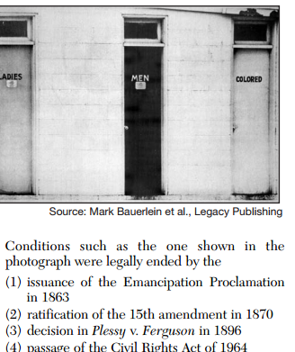
9)

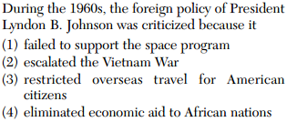
10) Answers:
1)4.. 2)4.. 3)3.. 4)4.. 5)3.. 6)3.. 7)1
8)3.. 9)4.. 10)2

